EXPLAINABLE AI-BASED CLINICAL DECISION SUPPORT SYSTEM FOR BREAST CANCER DIAGNOSIS
PROJECT REPORT

A Project report submitted in partial fulfillment of the requirements for the award of the degree of

BACHELOR OF SCIENCE
in
ARTIFICIAL INTELLIGENCE AND MACHINE LEARNING

Submitted by
RITHU P
(Reg. No: 231AI047)

Under the Guidance of
Dr. S. Saranya M.Sc., M.C.A., M.Phil., Ph.D.
Associate Professor & Head



DEPARTMENT OF ARTIFICIAL INTELLIGENCE AND MACHINE LEARNING

Dr. N.G.P. ARTS AND SCIENCE COLLEGE
(An Autonomous Institution, Affiliated to Bharathiar University, Coimbatore)
Approved by Government of Tamil Nadu & Accredited by NAAC with A++ Grade (3rd Cycle -3.64 CGPA)
Dr. N.G.P.-Kalapatti Road, Coimbatore-641 048, Tamil Nadu, India.
Website: www.drngpasc.ac.in | Email: info@drngpasc.ac.in. | Phone: +91-422-2369100

MARCH – 2026

DECLARATION

Ms. RITHU P (Reg. No: 231AI047) hereby declare that the project report entitled “EXPLAINABLE AI-BASED CLINICAL DECISION SUPPORT SYSTEM FOR BREAST CANCER DIAGNOSIS” submitted in partial fulfillment of the requirement for the award of the degree of Bachelor of Science in Artificial Intelligence and Machine Learning is a record of original work done during the period of internship under the supervision and guidance of Dr. S. Saranya M.Sc., M.C.A., M.Phil., Ph.D., Associate Professor & Head, Department of Artificial Intelligence and Machine Learning, Dr. N. G. P. Arts and Science College, Coimbatore - 48, and it has not formed the basis of the award of any Degree/ Diploma/ Associateship/ Fellowship or other similar title to any candidate of any university.

Place : Coimbatore | RITHU P
Date : | (Reg . no: 231AI047)

CERTIFICATE

This is to certify that the project report entitled “EXPLAINABLE AI-BASED CLINICAL DECISION SUPPORT SYSTEM FOR BREAST CANCER DIAGNOSIS” submitted in partial fulfilment of the requirement for the award of the degree of Bachelor of Science in Artificial Intelligence and Machine Learning at the Bharathiar University is a record of original work done by RITHU P (Reg. No: 231AI047) during the period (2023 - 2026) of her study in Department of Artificial Intelligence and Machine Learning, Dr.N.G.P. Arts and Science College, Coimbatore-48 under my supervision and guidance, and the internship report has not formed the basis for the award of any Degree/ Diploma/ Associateship/ Fellowship or other similar title to any candidate of any university.

(Dr. S. Saranya) | (Dr. S. Saranya) | (Dr. S. Saravanan)
Internship Guide | Associate Professor and Head | Principal
Place: Coimbatore
Date:

Viva-voce Examination held on………………………………..

Internal Examiner | External Examiner

ACKNOWLEDGEMENT
This internship report was the most significant accomplishment in my life and it would not have been possible without the blessing of God almighty and those who supported and believed in my caliber.
I record my deep sense of gratitude to Dr. NALLA. G. PALANISWAMI, M.D, AB (USA), Chairman, Kovai Medical Center Research and Educational Trust and Dr. THAVAMANI. D. PALANISWAMI, M.D, AB (USA), Secretary, Dr. N. G. P. Arts and Science College, Coimbatore for providing me an opportunity to carry out internship successfully.
I record my sincere thanks to Dr. S. Saravanan, M.Com., M.Phil., Ph.D., Principal, Dr. N.G.P. Arts and Science College, Coimbatore, for every help he rendered before and during the period of internship.
I express my sincere thanks to Dr. S. Saranya, M. Sc., M.C.A., M. Phil., Ph. D., Associate Professor and Head, Department of Artificial Intelligence and Machine Learning, Dr. N.G.P. Arts and Science College, Coimbatore for showing sustained interest and providing help throughout the period of this work.
I would like to extend the sincere thanks to my guide Dr. S. Saranya, M. Sc., M.C.A., M. Phil., Ph. D., Associate Professor and Head, Department of Artificial Intelligence and Machine Learning, Dr. N.G.P. Arts and Science College, Coimbatore for her exemplary guidance and encouragement.
I take this opportunity to acknowledge my sincere thanks to all the staff members of the Department of Artificial Intelligence and Machine Learning for their constant inspiration, assistance and resourceful guidance for the completion of this internship successfully.
I express my sincere thanks to our family and friends for their encouragement, love, prayer, moral support, advice and sacrifice without which I would not have been able to pursue the course of this study.

RITHU P

COMPANY PROFILE

Established in 2001, they offer assistance for all essential business functions. Customer centricity is at the core of Prodigy Infotech Chennai Pvt Ltd in Egmore, Chennai and it is this belief that has led the business to build long-term relationships.
Prodigy Infotech is a tech company that offers software development services, educational resources, and internships.

Software development:
Prodigy Infotech offers custom software development services for businesses. Their team of software developers work with businesses to design, develop, test, and maintain software solutions.

Educational resources:
Prodigy Infotech offers educational resources and opportunities for aspiring developers and professionals.

Internships:
Prodigy Infotech offers internships that simulate real-world work experiences. Interns work on projects and assignments relevant to their field of study.
Prodigy Infotech has an overall rating of 3.6 out of 5, based on over 71 reviews left anonymously by employees. 59% of employees would recommend working at Prodigy Infotech to a friend and 41% have a positive outlook for the business. This rating has decreased by 18% over the last 12 months.

ABSTRACT

The project provides an overview of the development of an Explainable AI-based Clinical Decision Support System (CDSS) for breast cancer diagnosis using mammogram images. The work focused on understanding and applying core concepts of artificial intelligence, deep learning, and medical image processing, while gaining hands-on experience in building real-world healthcare applications. Throughout the project, convolutional neural networks were explored for automated feature extraction and classification of mammogram images into benign and malignant categories. A key outcome of the project was the implementation of an explainable diagnostic model using techniques such as Grad-CAM and LIME, which visually highlight the regions of interest influencing the model’s predictions. This explainability component enhances transparency and supports clinical trust in AI-driven decisions. Additionally, a web-based interface was developed to enable image upload, prediction visualization, and result interpretation in an interactive manner. Overall, this project bridged the gap between theoretical knowledge and practical implementation by integrating deep learning, explainable AI, and web deployment. It strengthened technical skills in medical imaging, model interpretability, and system deployment, while demonstrating the potential of explainable artificial intelligence in supporting accurate and transparent healthcare decision-making.

TABLE OF CONTENTS

CHAPTER | TITLE | PAGE NO
1 | INTRODUCTION | 1
2 | BREAST CANCER AND MAMMOGRAPHY | 3
3 | MEDICAL IMAGE PROCESSING TECHNIQUES | 5
4 | DEEP LEARNING AND CONVOLUTIONAL NEURAL NETWORKS | 8
5 | DATASET AND DATA HANDLING | 12
6 | EXPLAINABLE ARTIFICIAL INTELLIGENCE (XAI) | 15
7 | CLINICAL DECISION SUPPORT SYSTEM (CDSS) | 17
8 | SYSTEM ARCHITECTURE AND DEPLOYMENT | 19
9 | ETHICAL CONSIDERATIONS AND LIMITATIONS
10 | FUTURE ENHANCEMENT
11 | OUTPUT

CHAPTER 1
INTRODUCTION

Introduction

Breast cancer is one of the most common and life-threatening diseases affecting women worldwide. Early detection plays a crucial role in improving survival rates and treatment outcomes. Mammography is the most widely used imaging technique for breast cancer screening, as it helps in identifying abnormal tissue growths at an early stage. However, interpreting mammogram images is a complex and time-consuming task due to factors such as low image contrast, dense breast tissue, and subtle visual differences between benign and malignant lesions.
In recent years, artificial intelligence (AI) and deep learning techniques have shown significant potential in medical image analysis. Convolutional Neural Networks (CNNs) are capable of automatically learning complex features from mammogram images and have achieved promising results in breast cancer classification. Despite their high accuracy, most deep learning models function as black-box systems, meaning they do not provide clear explanations for their predictions. This lack of transparency limits their acceptance in clinical environments, where understanding the reasoning behind a diagnosis is essential.
To address these challenges, there is a growing need for Explainable Artificial Intelligence (XAI) systems that combine accurate predictions with meaningful explanations. An Explainable AI-based Clinical Decision Support System (CDSS) can assist radiologists by not only identifying whether a breast tumor is benign or malignant but also by visually highlighting the regions of the mammogram that influenced the decision. Such systems enhance trust, support clinical decision-making, and reduce diagnostic errors, making them valuable tools in modern healthcare.

1.2 Objectives

The main objectives of this project are as follows:
- To design and develop an Explainable AI-based Clinical Decision Support System (CDSS) for breast cancer diagnosis.
- To detect and classify breast cancer as benign or malignant using mammogram images.
- To implement a Convolutional Neural Network (CNN) model for automated feature extraction and classification.
- To integrate explainability techniques such as Grad-CAM and LIME to provide transparent and interpretable model predictions.
- To preprocess mammogram images using noise removal, enhancement, normalization, and segmentation techniques to improve model performance.
- To develop a web-based interface that allows users to upload mammogram images and view predictions along with visual explanations.
- To support radiologists in clinical decision-making by providing accurate, reliable, and interpretable diagnostic insights.

CHAPTER 2
BREAST CANCER AND MAMMOGRAPHY

2.1 Overview of Breast Cancer
Breast cancer is a disease in which abnormal cells in the breast grow uncontrollably and form a tumor. These cancerous cells may remain confined to the breast or spread to nearby tissues and other parts of the body if not detected early. Breast cancer mainly affects women, although it can also occur in men in rare cases. According to global health statistics, breast cancer is one of the leading causes of cancer-related deaths among women, making early diagnosis and timely treatment extremely important.
Breast tumors are generally classified into two main types: benign and malignant. Benign tumors are non-cancerous and do not spread to other parts of the body, while malignant tumors are cancerous and can invade nearby tissues and metastasize to distant organs. Distinguishing between these two types at an early stage plays a vital role in deciding the treatment plan and improving patient survival rates.

2.2 Importance of Early Detection
Early detection of breast cancer significantly increases the chances of successful treatment and recovery. When cancer is identified in its early stages, treatment options such as surgery, radiation, and medication are more effective and less aggressive. Delayed diagnosis often leads to advanced-stage cancer, which is more difficult to treat and may reduce the patient’s quality of life.
Regular screening methods help in identifying breast abnormalities before symptoms become visible. Mammography is considered the most reliable and widely used screening technique for early breast cancer detection. It allows radiologists to observe internal breast structures and identify small masses or calcifications that may not be detectable through physical examination.

2.3 Mammography as a Diagnostic Tool
Mammography is a medical imaging technique that uses low-dose X-rays to examine breast tissue. It helps in identifying abnormalities such as lumps, masses, or microcalcifications that may indicate the presence of cancer. Mammograms provide detailed grayscale images that highlight differences in tissue density, which is essential for detecting early signs of breast cancer.
Despite its effectiveness, mammogram interpretation is challenging. The visual differences between healthy tissue, benign lesions, and malignant tumors can be very subtle. Factors such as dense breast tissue, noise in the images, and overlapping structures often make diagnosis difficult. This complexity increases the risk of misinterpretation, especially in early-stage cancer detection.

2.4 Mammogram Views: CC and MLO
Mammogram images are captured from different angles to provide a comprehensive view of breast tissue. The two standard views used in clinical practice are Cranio-Caudal (CC) and Medio-Lateral Oblique (MLO) views.
The CC view is taken from top to bottom and provides a clear image of the central breast region. The MLO view is captured at an angled side position and includes additional tissue near the chest wall and lymph nodes. Using both views helps radiologists examine the breast more thoroughly and reduces the chances of missing abnormalities.
Each patient typically has multiple mammogram images, including CC and MLO views of both the left and right breasts. These multiple views provide complementary information, which is essential for accurate diagnosis.

2.5 Challenges in Mammogram Interpretation
Interpreting mammogram images is a complex task that requires high expertise and experience. Radiologists must carefully analyze texture patterns, shapes, and density variations to distinguish between normal tissue and suspicious regions. Dense breast tissue can obscure lesions, making cancer harder to detect.
Another challenge is the presence of noise and low contrast in mammogram images. These factors can hide small abnormalities and increase the likelihood of false positives or false negatives. Additionally, manual diagnosis is time-consuming and subject to inter-observer variability, where different radiologists may interpret the same image differently.

2.6 Role of Computer-Aided Diagnosis
Manual interpretation of mammogram images is a challenging task for radiologists, as breast tissue structures can be complex and subtle abnormalities may be difficult to detect with the human eye alone. Factors such as image quality, dense breast tissue, fatigue, and time constraints can also affect diagnostic accuracy. To address these challenges, Computer-Aided Diagnosis (CAD) systems have been developed. These systems support radiologists by automatically analyzing mammogram images and identifying regions that may indicate abnormalities, thereby reducing the chances of missed detections.
CAD systems function as a supportive “second opinion” rather than replacing the radiologist. By highlighting suspicious areas and providing additional diagnostic insights, CAD tools help improve consistency and reduce variability in interpretations among different clinicians. This assistance is especially valuable in early-stage breast cancer detection, where small or faint lesions may otherwise go unnoticed. As a result, CAD systems contribute to improved detection rates and increased confidence in clinical decision-making.
Recent advancements in artificial intelligence, particularly deep learning, have significantly enhanced the capabilities of CAD systems. Deep learning-based models can automatically learn complex and meaningful patterns from large volumes of mammogram images, allowing them to accurately differentiate between benign and malignant tumors. However, despite their high performance, many AI-based CAD systems operate as “black boxes,” offering limited insight into how decisions are made. This lack of transparency raises concerns in clinical environments, highlighting the importance of developing explainable and trustworthy diagnostic systems that clinicians can understand, verify, and confidently use.

2.7 Need for Explainable AI in Mammography
In medical applications, achieving high accuracy is important, but it is not enough on its own. Doctors and radiologists need to understand the reasoning behind a model’s prediction before they can trust and use it in clinical practice. When an AI system predicts whether a mammogram is benign or malignant, clinicians must know what features or regions influenced that decision. Without this understanding, it becomes difficult to validate the results or rely on the system for critical medical decisions.
Explainable Artificial Intelligence (XAI) addresses this challenge by providing clear and understandable explanations for model predictions. In mammography, XAI techniques such as heatmaps, saliency maps, and region-based visualizations highlight the specific areas of the image that played a major role in the diagnosis. These visual explanations allow radiologists to compare AI-generated insights with their own clinical observations, making it easier to verify whether the model is focusing on medically relevant regions such as masses or calcifications.
By improving transparency, Explainable AI helps build trust between clinicians and AI systems. Rather than replacing human expertise, XAI-based models act as reliable decision-support tools that assist radiologists in making informed judgments. This collaboration between human knowledge and AI intelligence enhances diagnostic confidence, reduces the risk of errors, and promotes responsible and ethical use of artificial intelligence in mammography.

CHAPTER 3
MEDICAL IMAGE PROCESSING TECHNIQUES

3.1 Introduction to Medical Image Processing
Medical image processing is a crucial field that focuses on enhancing, analyzing, and interpreting images obtained from medical imaging modalities such as X-rays, mammography, MRI, CT scans, and ultrasound. These images play a vital role in diagnosing diseases and monitoring patient health. However, raw medical images often contain noise, low contrast, and irrelevant background information, which can affect accurate diagnosis. Medical image processing techniques help improve image quality and extract meaningful information, making them suitable for automated analysis.
In the context of breast cancer diagnosis, mammogram images require careful preprocessing before being analyzed by machine learning or deep learning models. Proper image processing ensures that important features such as masses, calcifications, and tissue patterns are clearly visible, enabling better model performance and reliable predictions.

3.2 Image Acquisition and Format Handling
Mammogram images are captured using specialized medical imaging equipment designed specifically for breast screening and diagnosis. These images are often stored in formats such as DICOM, which contains detailed medical and patient-related metadata, or in standard image formats like PNG or JPEG for easier visualization. Depending on the imaging device, hospital settings, and acquisition parameters, mammogram images can differ in resolution, brightness levels, contrast, and orientation. These variations make direct comparison and analysis challenging and require careful handling during the preprocessing stage.
Handling different image formats is an essential part of medical image processing. DICOM images, for example, must be read and converted into standard image arrays before they can be used for machine learning tasks. Additionally, images may appear in different orientations or contain unnecessary background regions that do not contribute to diagnosis. Proper format conversion and orientation correction ensure that the images are correctly interpreted by the system and maintain clinically meaningful information.
Before feeding the images into a deep learning model, they are converted into a consistent format and resized to a fixed dimension. Standardizing image size, resolution, and intensity range ensures uniformity across the dataset, which helps the model learn more effectively. This preprocessing step reduces computational complexity, simplifies the training process, and improves model stability and performance during classification.

3.3 Noise Removal
Noise is an unwanted disturbance in images that can obscure important details. In mammogram images, noise may arise due to sensor limitations or imaging conditions. Removing noise is essential to prevent the model from learning irrelevant patterns.
Common noise removal techniques include:
- Gaussian filtering
- Median filtering
- Bilateral filtering
These filters smooth the image while preserving important edges and structures, helping retain critical diagnostic information.

3.4 Image Enhancement
Mammogram images often have low contrast, making it difficult to distinguish between normal tissue and abnormal regions. Image enhancement techniques improve the visibility of important features by adjusting brightness and contrast.
One widely used enhancement method is Contrast Limited Adaptive Histogram Equalization (CLAHE). CLAHE enhances local contrast while preventing over-amplification of noise. This technique is especially useful in mammography, as it highlights subtle tissue variations and improves lesion visibility.

3.5 Image Normalization
Image normalization is a preprocessing technique used to scale pixel intensity values into a standard range, most commonly between 0 and 1. Mammogram images often have wide variations in brightness and contrast due to differences in imaging devices, exposure settings, and patient anatomy. Without normalization, these variations can affect how a deep learning model learns from the data and may lead to unstable or slow training.
Normalization plays a critical role in improving the performance of deep learning models. When pixel values are scaled consistently, the model can process images more efficiently and learn patterns more effectively. This step helps stabilize the training process, improves convergence speed, and reduces the chances of numerical instability during model optimization. As a result, the model becomes more reliable and consistent across different inputs.
By reducing the influence of lighting and intensity variations, normalization allows the model to focus on meaningful structural features such as tissue texture, mass shape, and boundary patterns. This ensures that the model’s predictions are based on clinically relevant information rather than differences in image brightness. Overall, image normalization contributes significantly to improved accuracy and robustness in mammogram classification tasks.

3.6 Image Resizing and Scaling
Deep learning models require input images of fixed size. Mammogram images come in different resolutions, which must be resized before feeding them into the model.
Resizing ensures computational efficiency and uniformity across the dataset. Care is taken to preserve the aspect ratio and important features during scaling to avoid distortion.

3.7 Segmentation and Region of Interest (ROI) Extraction
Segmentation is the process of dividing an image into meaningful regions. In mammography, segmentation helps isolate the breast area from the background and focus on regions that may contain abnormalities.
Region of Interest (ROI) extraction reduces irrelevant information and directs the model’s attention to suspicious areas. This improves classification accuracy and reduces computational complexity.

3.8 Data Augmentation
Medical datasets are often limited in size. Data augmentation artificially increases dataset diversity by applying transformations such as rotation, flipping, zooming, and shifting.
These techniques help prevent overfitting and improve the model’s ability to generalize to unseen images. Augmentation is particularly useful in deep learning-based medical image analysis.

3.9 Feature Extraction for Deep Learning
In traditional image processing, features such as texture, shape, and edges were manually extracted. However, deep learning models automatically learn these features through convolutional layers.
Medical image processing prepares the input images in a way that allows CNNs to learn meaningful hierarchical features effectively, leading to improved diagnostic performance.

3.10 Importance of Preprocessing in Medical AI Systems
Effective preprocessing is a foundational step in medical AI systems. Poor preprocessing can lead to inaccurate predictions, while well-processed images significantly improve model reliability.
In breast cancer diagnosis, preprocessing ensures that the deep learning model focuses on clinically relevant regions and patterns. It also supports explainability by enabling clearer visualization of attention regions in techniques like Grad-CAM.

CHAPTER 4
DEEP LEARNING AND CONVOLUTIONAL NEURAL NETWORKS

4.1 Introduction to Deep Learning
Deep learning is a subfield of artificial intelligence that focuses on training models to learn complex patterns from large amounts of data. It is inspired by the structure and functioning of the human brain, where information is processed through interconnected neurons. Deep learning models use multiple layers to progressively learn higher-level representations from raw input data.
In recent years, deep learning has achieved remarkable success in image classification, speech recognition, and medical image analysis. Unlike traditional machine learning methods that rely on manual feature extraction, deep learning models automatically learn features directly from data. This capability makes deep learning particularly suitable for medical applications, where patterns are complex and difficult to define manually.

4.2 Artificial Neural Networks (ANNs)
Artificial Neural Networks (ANNs) are the foundation of deep learning. An ANN consists of an input layer, one or more hidden layers, and an output layer. Each layer contains interconnected neurons that process information by applying weights and activation functions.
In a neural network, each neuron receives input values, multiplies them by weights, adds a bias, and passes the result through an activation function. Activation functions introduce non-linearity, enabling the network to learn complex relationships. Common activation functions include ReLU, Sigmoid, and Softmax.

4.3 Limitations of Traditional Neural Networks in Image Processing
Traditional fully connected neural networks are not well-suited for image data because images contain a large number of pixels. Flattening images into one-dimensional vectors leads to loss of spatial information and increases computational complexity.
These limitations make it difficult for traditional neural networks to capture important visual patterns such as edges, textures, and shapes. This challenge led to the development of Convolutional Neural Networks, which are specifically designed for image-related tasks.

4.4 Convolutional Neural Networks (CNNs)
Convolutional Neural Networks (CNNs) are a specialized type of neural network designed for processing grid-like data such as images. CNNs preserve spatial relationships between pixels and efficiently learn hierarchical features.
CNNs consist of several layers, including convolutional layers, pooling layers, and fully connected layers. Each layer plays a specific role in extracting and processing visual information from images.

4.5 Convolutional Layer
The convolutional layer is the core component of a CNN. It uses small filters (kernels) that slide across the input image to detect local features such as edges, corners, and textures. Each filter generates a feature map that highlights the presence of specific patterns in the image.
In mammogram analysis, convolutional layers help detect important structures such as masses, calcifications, and tissue irregularities, which are critical for breast cancer diagnosis.

4.6 Activation Functions
Activation functions introduce non-linearity into the network, allowing it to learn complex patterns. The most commonly used activation function in CNNs is the Rectified Linear Unit (ReLU), which outputs the input directly if it is positive and zero otherwise.
For binary classification tasks such as benign vs malignant prediction, the Sigmoid activation function is commonly used in the output layer, as it produces values between 0 and 1 representing probability.

4.7 Pooling Layer
Pooling layers reduce the spatial dimensions of feature maps while retaining important information. This helps decrease computational complexity and prevents overfitting.
Max pooling is commonly used in CNNs, where the maximum value from a region is selected. Pooling layers help make the model more robust to small variations in image position and scale.

4.8 Fully Connected Layer
Fully connected layers connect every neuron in one layer to every neuron in the next layer. These layers combine features learned by convolutional layers to perform final classification.
In breast cancer classification, fully connected layers analyze learned features and output a prediction indicating whether the mammogram corresponds to a benign or malignant case.

4.9 Loss Function and Optimization
The loss function measures the difference between predicted output and actual labels. For binary classification problems, Binary Cross-Entropy is commonly used.
Optimization algorithms such as Adam or Stochastic Gradient Descent (SGD) are used to minimize the loss function by updating model weights during training. Efficient optimization ensures faster convergence and improved performance.

4.10 Training and Validation Process
During training, the dataset is divided into training and validation sets. The model learns patterns from training data, while validation data is used to evaluate performance and prevent overfitting.
Monitoring validation loss and accuracy helps in tuning hyperparameters and selecting the best-performing model.

4.11 CNNs in Medical Image Analysis
CNNs have shown exceptional performance in medical imaging tasks such as tumor detection, disease classification, and segmentation. Their ability to learn discriminative features directly from images makes them highly effective for mammogram analysis.
However, CNNs often operate as black-box models, making it difficult to understand their decision-making process. This limitation highlights the importance of integrating explainable AI techniques into CNN-based systems.

CHAPTER 5
DATASET AND DATA HANDLING

5.1 Introduction
In any machine learning or deep learning project, the quality of the dataset plays a crucial role in determining the performance of the model. In medical applications, especially breast cancer diagnosis, handling the dataset carefully is extremely important because incorrect or biased data can lead to unreliable predictions. This chapter describes the dataset used in the project and explains how the data is organized, processed, and handled to ensure accurate and ethical model training.

5.2 Dataset Description
The dataset used in this project is the Curated Breast Imaging Subset of the Digital Database for Screening Mammography (CBIS-DDSM). It is a widely used and publicly available dataset designed specifically for breast cancer research. The dataset contains mammogram images that are pre-labeled by medical experts based on pathology reports.
The images in the dataset are categorized into two main classes:
- Benign – non-cancerous tumors
- Malignant – cancerous tumors
Each mammogram image corresponds to a specific patient and includes important metadata such as patient ID, breast side, view type, and pathology label.

5.3 Mammogram Views and Multiple Images per Patient
Each patient in the CBIS-DDSM dataset typically has multiple mammogram images taken from different angles. The most common views are:
- Cranio-Caudal (CC)
- Medio-Lateral Oblique (MLO)
Both views are captured for the left and right breasts, resulting in multiple images for a single patient. These multiple views provide complementary information and help in better understanding breast tissue patterns. In this project, all images belonging to a patient are treated carefully to ensure consistency during training and evaluation.

5.4 Data Labeling
Data labeling is the process of assigning correct class labels to images. In CBIS-DDSM, labels are derived from verified pathology reports, making them reliable and medically accurate. All mammogram images associated with a specific lesion share the same pathology label.
The two labels used in this project are:
- 0 – Benign
- 1 – Malignant
Accurate labeling is critical for training the deep learning model to correctly differentiate between benign and malignant cases.

5.5 Data Organization
To simplify model training, the dataset is organized into a structured folder format. Images are grouped based on their class labels and further divided into training, validation, and testing sets.
A typical folder structure is as follows:
dataset/
├── train/
│ ├── benign/
│ └── malignant/
├── val/
│ ├── benign/
│ └── malignant/
└── test/
├── benign/
└── malignant/
This structure allows easy loading of images using deep learning frameworks such as TensorFlow and Keras.

5.6 Data Splitting Strategy
Proper data splitting is essential to evaluate the model’s generalization ability. In medical imaging, it is important to perform patient-wise splitting rather than image-wise splitting. This means that all images from a single patient are placed in only one set, either training, validation, or testing.
Patient-wise splitting prevents data leakage, where the model might see similar images from the same patient during both training and evaluation, leading to misleadingly high accuracy.

5.7 Handling Class Imbalance
Medical datasets often suffer from class imbalance, where one class contains more samples than the other. In breast cancer datasets, benign cases are often more common than malignant cases.
To address this issue, techniques such as:
- Data augmentation for minority class
- Class weighting during training
- Balanced batch sampling
are applied. These techniques help the model learn both classes effectively and avoid biased predictions.

5.8 Data Augmentation
Data augmentation artificially increases the size of the training dataset by applying transformations such as rotation, flipping, zooming, and shifting. These operations simulate real-world variations and help the model generalize better.
Augmentation is applied only to the training dataset and not to validation or test datasets, ensuring fair evaluation.

5.9 Data Preprocessing Pipeline
Before feeding images into the CNN model, a preprocessing pipeline is applied. This includes:
- Noise removal
- Contrast enhancement
- Normalization
- Resizing
This pipeline ensures that all images are in a standardized format and are suitable for deep learning-based analysis.

5.10 Ethical Considerations in Data Handling
Handling medical data requires ethical responsibility. The CBIS-DDSM dataset is anonymized, meaning patient identities are protected. This project strictly uses publicly available data and follows ethical guidelines for medical research.
The system is designed as a clinical decision support tool and not as a replacement for medical professionals.

CHAPTER 6
EXPLAINABLE ARTIFICIAL INTELLIGENCE (XAI)

6.1 Introduction to Explainable Artificial Intelligence
Explainable Artificial Intelligence (XAI) refers to methods and techniques that make the decisions of artificial intelligence models understandable to humans. Traditional AI and deep learning models often act as black boxes, where the final prediction is visible, but the reasoning behind it is not clear. In sensitive domains such as healthcare, this lack of transparency can limit trust and acceptance of AI systems.
In medical diagnosis, it is important not only to know what the prediction is, but also why the prediction was made. Explainable AI helps bridge this gap by providing insights into how a model arrives at a decision. This improves confidence among medical professionals and supports better clinical decision-making.

6.2 Need for Explainability in Medical AI
Healthcare applications involve high risk, where incorrect predictions can have serious consequences. Doctors and radiologists must be able to justify diagnostic decisions, especially when they affect patient treatment. Therefore, AI systems used in healthcare must be transparent, reliable, and interpretable.
Explainability allows clinicians to verify whether the AI model focuses on medically relevant regions of an image rather than irrelevant background areas. It also helps in identifying model errors, biases, and limitations. As a result, XAI plays a critical role in increasing trust, safety, and ethical responsibility in medical AI systems.

6.3 Black-Box Nature of Deep Learning Models
Deep learning models, especially Convolutional Neural Networks (CNNs), are made up of many interconnected layers and a very large number of parameters. These layers work together to automatically learn complex patterns from medical images such as mammograms. While this complexity allows CNNs to achieve high accuracy, it also makes their internal decision-making process difficult to understand. Unlike traditional rule-based systems, CNNs do not provide clear explanations of how specific features influence the final output.
The interactions between convolutional layers, activation functions, and fully connected layers create a highly non-linear learning process. As information passes through these layers, features are gradually transformed from simple patterns like edges to complex representations such as masses or abnormal tissue regions. However, these transformations occur inside the network and are not directly visible to users. As a result, it becomes challenging for clinicians to determine why the model predicted a mammogram as benign or malignant.
This lack of interpretability, often referred to as the “black-box” nature of deep learning models, poses a significant challenge in clinical environments. Medical decisions require accountability, trust, and clear justification, especially when patient outcomes are involved. Explainable Artificial Intelligence (XAI) techniques address this problem by offering visual or logical explanations of model behavior. By revealing which image regions or features influenced a prediction, XAI helps clinicians understand, validate, and confidently use AI systems as supportive diagnostic tools rather than unquestionable decision-makers.

6.4 Categories of Explainable AI Techniques
Explainable Artificial Intelligence (XAI) techniques are developed to help users understand how machine learning models make decisions. These techniques can be broadly classified into two main categories: model-specific methods and model-agnostic methods. Each category serves a different purpose and offers unique advantages depending on the type of model and application. Understanding these categories is important when applying XAI in sensitive domains such as medical imaging.
Model-specific XAI methods are designed to work with particular types of machine learning models, especially deep learning models like Convolutional Neural Networks (CNNs). These methods utilize internal information from the model, such as gradients, activation maps, or feature layers, to explain predictions. Techniques like Grad-CAM highlight the regions in a mammogram image that strongly influence the model’s decision. Because these methods use the internal structure of the model, they often provide detailed and accurate visual explanations.
Model-agnostic XAI methods, on the other hand, can be applied to any machine learning model regardless of its internal architecture. These techniques treat the model as a black box and analyze how changes in input affect the output. LIME is a commonly used model-agnostic method that explains predictions by approximating the model’s behavior locally. Both model-specific and model-agnostic techniques are valuable in medical imaging, as they offer flexibility and transparency based on different clinical and technical requirements.

6.5 Gradient-weighted Class Activation Mapping (Grad-CAM)
Gradient-weighted Class Activation Mapping, commonly known as Grad-CAM, is a widely used explainable AI technique that helps visualize which regions of an image influence a deep learning model’s prediction. Grad-CAM is a model-specific method, mainly applied to Convolutional Neural Networks. It works by analyzing how important each feature map in the final convolutional layer is for a particular prediction by computing the gradient of the predicted class score with respect to those feature maps.
Using these gradients, Grad-CAM generates a heatmap that highlights the areas of the image that contribute most strongly to the model’s decision. Regions with higher influence appear as brighter or warmer colors on the heatmap, while less important areas appear darker. In mammogram analysis, this allows the system to visually indicate suspicious regions such as abnormal tissue structures, masses, or calcifications that led the model to classify the image as benign or malignant.
One of the key advantages of Grad-CAM is that it provides intuitive and easily understandable visual explanations without requiring any changes to the original model architecture. This makes it simple to integrate into existing deep learning pipelines. By offering clear visual insights into model behavior, Grad-CAM helps radiologists verify AI predictions, build trust in the system, and use AI as a supportive tool in clinical decision-making.

6.6 Local Interpretable Model-Agnostic Explanations (LIME)
Local Interpretable Model-Agnostic Explanations, commonly known as LIME, is an explainable AI technique that helps explain individual predictions made by machine learning models. LIME is model-agnostic, meaning it can be applied to any type of classification model without requiring access to its internal structure. Instead of trying to explain the entire model, LIME focuses on understanding why a model made a specific prediction for a single input image.
LIME works by generating multiple slightly modified versions of the original input image and observing how the model’s predictions change in response to these variations. In image-based applications, the image is divided into small meaningful regions called superpixels. LIME then selectively hides or alters these superpixels and analyzes their impact on the prediction. Based on this analysis, it highlights regions that positively or negatively influence the model’s decision, making the explanation easier to interpret.
One of the main advantages of LIME is its flexibility and simplicity. Since it treats the model as a black box, it can be used with deep learning models, traditional machine learning models, or hybrid systems. By providing localized explanations for individual predictions, LIME helps clinicians and users understand model behavior at a case-specific level, supporting transparency, trust, and informed decision-making in medical image analysis.

6.7 Comparison of Grad-CAM and LIME
Grad-CAM and LIME are two widely used explainable AI techniques, each offering a different approach to understanding model predictions. Grad-CAM is a model-specific method that uses internal information from deep learning models, particularly CNNs, to identify important regions in an image. By analyzing gradients and feature maps, Grad-CAM provides a broad visual overview of the areas that most strongly influence the model’s decision. This makes it especially useful for understanding overall attention patterns in medical images such as mammograms.
LIME, on the other hand, is a model-agnostic technique that focuses on explaining individual predictions. Instead of relying on internal model parameters, LIME studies how the model’s output changes when small parts of the input image are modified. By dividing the image into superpixels and evaluating their influence, LIME provides a localized explanation that highlights specific regions contributing positively or negatively to a single prediction. This makes LIME useful for case-by-case analysis and detailed interpretation of specific images.
When Grad-CAM and LIME are used together, they offer complementary insights into model behavior. Grad-CAM helps visualize global attention patterns, while LIME provides localized explanations for individual decisions. Combining both techniques improves overall interpretability, strengthens clinician trust, and enhances diagnostic confidence. This dual approach ensures that AI predictions are not only accurate but also transparent and clinically meaningful.

6.8 Role of XAI in Clinical Decision Support Systems
In a Clinical Decision Support System (CDSS), explainability plays a vital role in enabling effective collaboration between humans and artificial intelligence. Medical professionals must understand how and why an AI system arrives at a particular prediction before using it in patient care. XAI helps make AI decisions transparent by providing clear explanations, allowing radiologists to interpret results with confidence. This transparency is especially important in healthcare, where every decision can have serious consequences.
By incorporating XAI techniques, a CDSS allows clinicians to validate AI predictions against their own medical knowledge and experience. Visual explanations such as heatmaps and highlighted regions help radiologists confirm whether the model is focusing on clinically relevant areas in mammogram images. This shared understanding reduces uncertainty, improves trust in AI-assisted diagnosis, and supports more informed clinical decision-making.
Integrating XAI into CDSS also ensures ethical and responsible use of artificial intelligence in healthcare. Rather than replacing doctors, the system acts as a supportive tool that enhances human expertise. By promoting transparency, accountability, and human oversight, XAI-based CDSS become more reliable and acceptable for real-world medical applications, ultimately improving patient care and diagnostic outcomes.

6.9 Benefits of Explainable AI
- One of the most important benefits of Explainable AI is that it improves trust and acceptance of AI systems. When users, especially medical professionals, can clearly see how an AI model arrives at its predictions, they are more likely to trust and use it in real-world scenarios. Visual explanations and understandable reasoning help reduce fear and uncertainty around AI, making it easier for clinicians to rely on AI as a supportive diagnostic tool rather than a hidden or mysterious system.
- Another key benefit of Explainable AI is that it enables validation of AI predictions. XAI allows doctors to compare AI-generated results with their own clinical knowledge and observations. By highlighting important regions in medical images or explaining influential features, clinicians can verify whether the model’s decision is medically meaningful. This validation helps reduce incorrect diagnoses and ensures that AI outputs are consistent with clinical standards.
- Explainable AI also helps in detecting model errors and biases. By making the model’s decision-making process visible, XAI allows developers and clinicians to identify cases where the model focuses on irrelevant or misleading features. This insight helps improve model quality, reduce bias in training data, and enhance fairness. As a result, XAI supports ethical and responsible AI use by promoting transparency, accountability, and continuous system improvement.

CHAPTER 7
CLINICAL DECISION SUPPORT SYSTEM (CDSS)

7.1 Introduction to Clinical Decision Support Systems
A Clinical Decision Support System (CDSS) is a computer-based system designed to assist healthcare professionals in making informed clinical decisions. It provides relevant information, recommendations, and insights at the right time to improve the quality of patient care. CDSS does not replace doctors or radiologists but supports them by offering additional analytical insights based on data and clinical knowledge.
In modern healthcare, the increasing volume of medical data and the complexity of diagnostic procedures make it challenging for clinicians to analyze all information manually. CDSS helps manage this complexity by combining medical data with intelligent algorithms, enabling faster and more accurate decision-making.

7.2 Role of CDSS in Medical Imaging
Medical imaging is a crucial tool in the diagnosis and monitoring of many diseases, including breast cancer. Images such as mammograms provide detailed information about internal tissue structures, but interpreting these images requires high levels of expertise and experience. Even skilled radiologists may face challenges due to factors like complex tissue patterns, dense breast tissue, fatigue, or time pressure. These challenges can sometimes lead to missed findings or variations in interpretation among different clinicians.
Clinical Decision Support Systems (CDSS) play an important role in addressing these challenges by assisting radiologists during image analysis. A CDSS uses computational techniques to automatically analyze medical images and highlight regions that may contain abnormalities. By acting as a supportive second opinion, CDSS helps reduce diagnostic variability and improves consistency across different interpretations. This assistance is especially valuable in large-scale screening programs where radiologists must review a high volume of images.
In breast cancer diagnosis, a CDSS can process mammogram images to detect suspicious regions such as masses or calcifications and provide classification results indicating whether the findings are benign or malignant. By presenting these results along with visual explanations, the system helps radiologists focus on critical cases that require closer attention. This not only improves diagnostic efficiency but also supports earlier detection, leading to better patient outcomes and more effective clinical decision-making.

7.3 Need for CDSS in Breast Cancer Diagnosis
Breast cancer diagnosis is a complex and challenging process that relies heavily on the careful interpretation of mammogram images. These images often contain very subtle differences between benign and malignant tissues, making accurate detection difficult even for experienced radiologists. Factors such as dense breast tissue, low contrast, image noise, and overlapping structures can hide important signs of cancer. In addition, radiologists are required to review a large number of screening cases, which can lead to fatigue and increase the risk of human error.
A Clinical Decision Support System (CDSS) helps address these challenges by providing automated and consistent analysis of mammogram images. By acting as a reliable second opinion, a CDSS supports radiologists in identifying suspicious regions and classifying findings more accurately. This assistance helps reduce both false negatives, where cancer is missed, and false positives, which can lead to unnecessary anxiety and procedures. Overall, the use of CDSS supports early detection, improves diagnostic confidence, and enhances the efficiency of breast cancer screening programs.

7.4 Architecture of the Proposed CDSS
The proposed Clinical Decision Support System (CDSS) is designed as an integrated and structured framework that combines image processing, deep learning, and explainable AI into a single system. The process begins with the input of mammogram images, which are uploaded through a user interface. These images may vary in quality, size, and contrast depending on how they were acquired. Therefore, the first step of the system focuses on preprocessing the images to improve clarity and consistency.
During preprocessing, techniques such as noise removal, image enhancement, resizing, and normalization are applied to the mammogram images. These steps help highlight important tissue structures and ensure that the images are in a suitable format for analysis by the deep learning model. Once preprocessing is completed, the enhanced image is passed to a convolutional neural network (CNN) that has been trained to analyze mammograms and classify them as either benign or malignant. The model extracts meaningful features automatically and generates a prediction along with a confidence score.
To ensure transparency and trust, an explainability layer is integrated into the CDSS. Techniques such as Grad-CAM and LIME are used to generate visual explanations that highlight the regions of the mammogram that influenced the model’s decision. These explanations help clinicians understand and validate the prediction. Finally, all results, including the uploaded image, predicted class, confidence level, and explanation visualizations, are displayed through a web-based interface. This user-friendly interface allows radiologists to easily interact with the system and use it as a supportive tool in breast cancer diagnosis.

7.5 Integration of Explainable AI in CDSS
Explainable Artificial Intelligence (XAI) plays a central role in the proposed Clinical Decision Support System (CDSS) by making AI predictions transparent and understandable. Instead of providing only a final classification result, the system is designed to explain how the decision was made. This is especially important in medical applications, where clinicians need to trust and verify AI-assisted outcomes before using them in patient care.
By integrating XAI techniques such as Grad-CAM and LIME, the system generates visual explanations in the form of heatmaps and highlighted regions on mammogram images. These visuals clearly indicate the areas of the breast image that had the strongest influence on the model’s prediction. For example, if a particular region shows abnormal tissue patterns, the heatmap will emphasize that area, helping radiologists quickly identify suspicious findings.
This explainability enables radiologists to compare AI-generated insights with their own clinical observations, ensuring that the system’s decisions align with medical reasoning. As a result, the CDSS becomes more reliable and clinically acceptable. Rather than replacing human expertise, the integration of XAI ensures that the system acts as a supportive tool, enhancing diagnostic confidence, accountability, and ethical use of artificial intelligence in breast cancer diagnosis.

7.6 User Interaction and Workflow
The CDSS provides a user-friendly interface that allows radiologists or users to upload mammogram images easily. After uploading, the system processes the image, performs classification, and generates results within seconds.
The output includes:
- Predicted class (Benign or Malignant)
- Confidence score
- Visual explanations (heatmaps)
This streamlined workflow improves usability and integrates smoothly into existing diagnostic processes.

7.7 Advantages of CDSS
- Supports clinicians in accurate decision-making
- Reduces diagnostic errors
- Improves consistency in diagnosis
- Saves time and effort for radiologists
- Enhances early detection of breast cancer

7.8 Limitations of CDSS
- Dependent on dataset quality
- Requires clinical validation
- Should not be used as a standalone diagnostic tool
- May face challenges in real-world deployment
These limitations highlight the importance of careful design and responsible usage of CDSS in healthcare.

7.9 Ethical and Clinical Considerations
When developing and using a Clinical Decision Support System (CDSS), it’s very important to think about ethical issues. Ethical considerations mean making sure that the system respects patients’ rights and follows moral principles in healthcare. One major aspect is patient data privacy. This means that all information about patients must be kept safe and confidential. The CDSS in this project uses anonymized datasets, which means that any personal information that could identify a patient has been removed. This protects patients’ privacy while still allowing the system to learn from medical data.
Another key ethical concern is transparency. Healthcare providers and patients should understand how the CDSS works. They should know that it provides suggestions based on data, but does not make decisions on its own. This builds trust and ensures that the system is used responsibly. Accountability is also important. If the CDSS makes an incorrect suggestion, it should be clear that the final responsibility for the patient’s care lies with the healthcare professional, not the system.
From a clinical perspective, the CDSS is intended to support medical professionals, not replace them. It can help doctors and nurses make better decisions by providing additional information, analysis, or recommendations. However, the expert judgment of healthcare professionals is always the most important factor in clinical decisions. For example, a doctor may consider a patient’s overall health, personal preferences, and other factors that a CDSS cannot fully capture.
In summary, ethical and clinical considerations ensure that the CDSS is safe, reliable, and useful. It respects patient privacy, explains its suggestions clearly, and supports, but does not replace, the expertise of healthcare professionals. This approach helps improve patient care while maintaining trust and accountability in healthcare.

CHAPTER 8
SYSTEM ARCHITECTURE AND DEPLOYMENT

8.1 Introduction
System architecture defines how different components of a system interact with each other to achieve the desired functionality. In a medical AI application, a well-designed architecture ensures reliability, scalability, and ease of use. Deployment refers to making the trained model accessible through a user interface so that it can be used in real-world scenarios.
This chapter explains the overall architecture of the proposed Explainable AI-based Clinical Decision Support System (CDSS) and describes how the system is deployed as a web-based application for breast cancer diagnosis.

8.2 Overall System Architecture
The proposed system follows a modular architecture, where each component performs a specific function. The major components include data input, preprocessing, model inference, explainability, and user interface. This modular design makes the system easy to understand, maintain, and enhance in the future.
The architecture begins with mammogram image acquisition, followed by image preprocessing to improve quality. The processed image is then passed to the trained CNN model for classification. Explainability techniques are applied to generate visual explanations, and the final results are displayed through a web interface.

8.3 Data Flow in the System
The data flow in the system follows a sequential pipeline:
- The user uploads a mammogram image through the web interface.
- The image undergoes preprocessing steps such as resizing, normalization, and enhancement.
- The preprocessed image is passed to the trained CNN model.
- The model predicts whether the image is benign or malignant.
- Explainability modules generate visual explanations.
- Results are displayed to the user.
This structured flow ensures smooth and efficient system operation.

8.4 Preprocessing Module
The preprocessing module prepares the mammogram image for analysis. It removes noise, enhances contrast, and standardizes the image size. These steps ensure that the input image is compatible with the trained model and improves prediction accuracy.
By isolating preprocessing as a separate module, the system maintains flexibility and allows easy updates or improvements.

8.5 Model Inference Module
The model inference module consists of a trained Convolutional Neural Network that performs classification. The model processes the preprocessed image and outputs a probability score indicating the likelihood of benign or malignant cancer.
This module is optimized for fast inference, ensuring quick response times for users.

8.6 Explainability Module
The explainability module integrates XAI techniques such as Grad-CAM and LIME. These techniques generate heatmaps and highlighted regions that show which parts of the mammogram influenced the model’s decision.
Explainability enhances transparency and allows clinicians to validate AI predictions, making the system more trustworthy and clinically acceptable.

8.7 User Interface Module
The user interface module provides an interactive and easy-to-use platform for users. Through the web application, users can upload mammogram images and view prediction results.
The interface displays:
- Uploaded mammogram image
- Predicted class (Benign/Malignant)
- Confidence score
- Explainability visualizations
This design ensures accessibility for both technical and non-technical users.

8.8 Deployment Strategy
The system is deployed as a web-based application using frameworks such as Flask or Streamlit. The trained model is saved and loaded during application runtime, enabling real-time predictions.
Web deployment allows the system to be accessed from different devices without requiring complex installations. This approach improves scalability and usability in clinical environments.

8.9 Scalability and Maintainability
The modular architecture allows easy integration of additional features such as new models, datasets, or explainability methods. The system can be scaled by deploying it on cloud platforms, enabling multiple users to access the application simultaneously.
Maintainability is enhanced through clear separation of components, making debugging and updates straightforward.

8.10 Security and Ethical Deployment Considerations
Security and privacy are critical in medical applications. The system uses anonymized data and restricts access to sensitive information. Ethical considerations include responsible AI usage, transparency, and human oversight in clinical decisions.
The CDSS is designed as a supportive tool and not as a replacement for medical professionals.

CHAPTER 9
ETHICAL CONSIDERATIONS AND LIMITATIONS

9.1 Introduction
Artificial Intelligence has the potential to transform healthcare by improving diagnostic accuracy and efficiency. However, when AI systems are used in medical applications, ethical responsibility becomes extremely important. Decisions made using AI can directly affect patient health and treatment outcomes. Therefore, it is essential to carefully consider ethical issues and system limitations while developing and deploying AI-based medical systems.
This chapter discusses the ethical considerations involved in the proposed Explainable AI-based Clinical Decision Support System (CDSS) for breast cancer diagnosis and highlights the limitations of the system.

9.2 Patient Data Privacy and Confidentiality
Medical data contains highly sensitive personal information. Protecting patient privacy is a fundamental ethical requirement in healthcare. In this project, only publicly available and anonymized datasets are used, ensuring that patient identities are not disclosed.
The system does not store personal identifiers and is designed to handle medical images responsibly. In real-world deployment, strict data protection regulations such as HIPAA and GDPR must be followed to ensure confidentiality and secure data handling.

9.3 Transparency and Explainability
Transparency is essential in medical AI systems. Clinicians must understand how a system arrives at a diagnosis in order to trust and validate its predictions. The proposed system integrates explainable AI techniques such as Grad-CAM and LIME to provide visual explanations for model decisions.
By highlighting important regions in mammogram images, the system ensures that predictions are based on clinically relevant features. This transparency supports ethical decision-making and accountability.

9.4 Human Oversight and Responsibility
AI-based CDSS are designed to assist medical professionals, not replace them. Final clinical decisions must always be made by qualified healthcare experts. Over-reliance on AI without human judgment can lead to serious ethical and medical risks.
The proposed system clearly positions itself as a supportive tool, encouraging human oversight and shared responsibility between AI systems and clinicians.

9.5 Bias and Fairness
AI models may inherit biases present in the training dataset. Factors such as limited demographic diversity or imbalanced class distribution can affect model performance across different patient groups.
To reduce bias, careful dataset selection, balanced training strategies, and performance evaluation are necessary. However, complete elimination of bias remains a challenge and must be acknowledged as a system limitation.

9.6 Clinical Validation and Reliability
While the system demonstrates promising results, it has not undergone extensive clinical trials. Real-world medical deployment requires rigorous validation under diverse conditions and patient populations.
The absence of large-scale clinical testing limits the immediate applicability of the system in hospital environments. Further validation is necessary before clinical adoption.

9.7 Technical Limitations
The system’s performance depends on the quality and size of the dataset. Poor-quality images, unseen imaging conditions, or variations in equipment may affect accuracy. Additionally, the model currently focuses only on binary classification (benign or malignant), which may not capture all clinical scenarios.
Explainability techniques provide insights but do not guarantee complete understanding of the model’s internal behavior.

9.8 Ethical Use and Regulatory Compliance
Ethical deployment of medical AI systems requires adherence to healthcare regulations and ethical guidelines. The system must comply with legal standards, ensure patient consent, and maintain transparency in decision-making.
Regulatory approval is essential before deploying AI systems in real clinical settings. This project serves as a research and educational model rather than a certified medical device.

CHAPTER 10
FUTURE ENHANCEMENT

10.1 Introduction
The proposed Explainable AI-based Clinical Decision Support System (CDSS) for breast cancer diagnosis demonstrates the effective use of deep learning and explainable AI techniques in medical image analysis. While the current system provides accurate classification and visual explanations, there are several opportunities to further enhance its capabilities.
This chapter outlines possible future enhancements that can improve the system’s accuracy, usability, scalability, and clinical relevance.

10.2 Expansion of Dataset
One of the most important future improvements is the inclusion of larger and more diverse datasets. Incorporating mammogram images from multiple sources, hospitals, and imaging devices can help the model generalize better across different populations.
Using datasets with varied age groups, breast densities, and imaging conditions can reduce bias and improve reliability.

10.3 Multi-Class Cancer Classification
Currently, the system performs binary classification (benign or malignant). Future versions can be extended to multi-class classification by identifying specific cancer subtypes or stages.
This enhancement would provide more detailed diagnostic insights and assist clinicians in treatment planning.

10.4 Integration of Additional Imaging Modalities
Future systems can integrate other imaging modalities such as ultrasound, MRI, or histopathology images. Combining multiple modalities can improve diagnostic accuracy by providing complementary information.
Multi-modal learning can help detect complex patterns that may not be visible in mammograms alone.

10.5 Advanced Deep Learning Models
More advanced deep learning architectures such as Vision Transformers, EfficientNet, or hybrid CNN-transformer models can be explored to improve performance.
Transfer learning and self-supervised learning techniques can also be applied to reduce dependency on labeled data.

10.6 Improved Explainability Techniques
Future enhancements can include more advanced explainability methods that provide both visual and textual explanations. Generating human-readable summaries of model decisions can further increase trust and interpretability.
This would make AI predictions easier to understand for both clinicians and patients.

10.7 Real-Time and Cloud-Based Deployment
Deploying the system on cloud platforms would enable real-time access and scalability. Cloud deployment can support multiple users simultaneously and allow integration with hospital information systems.
Mobile and tablet support can further improve accessibility in clinical settings.

10.8 Clinical Validation and Regulatory Approval
Future work should focus on clinical trials and validation studies in collaboration with healthcare professionals. This step is essential for regulatory approval and real-world medical use.
Obtaining certification from healthcare authorities would allow the system to be deployed as a certified medical decision support tool.

10.9 Patient-Centric Features
Future versions can include patient-centric features such as personalized risk assessment, follow-up recommendations, and report generation.
These features can help patients better understand their diagnosis and improve doctor–patient communication.

10.10 Ethical and Responsible AI Enhancements
Ongoing efforts can focus on bias detection, fairness evaluation, and ethical AI monitoring. Implementing audit logs and performance tracking can ensure responsible and transparent AI usage.
This ensures long-term trust and acceptance of AI systems in healthcare.

CHAPTER 11
OUTPUT

HOMEPAGE:
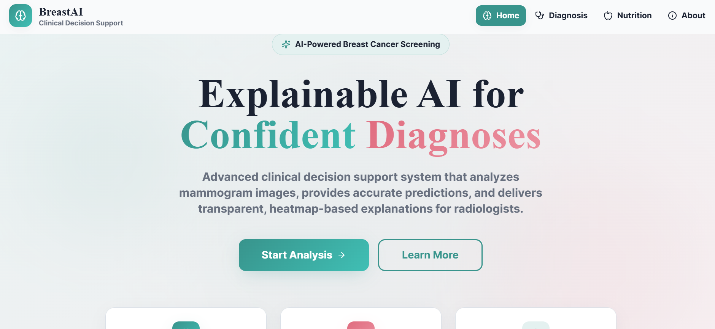

MODULE: DIAGNOSIS
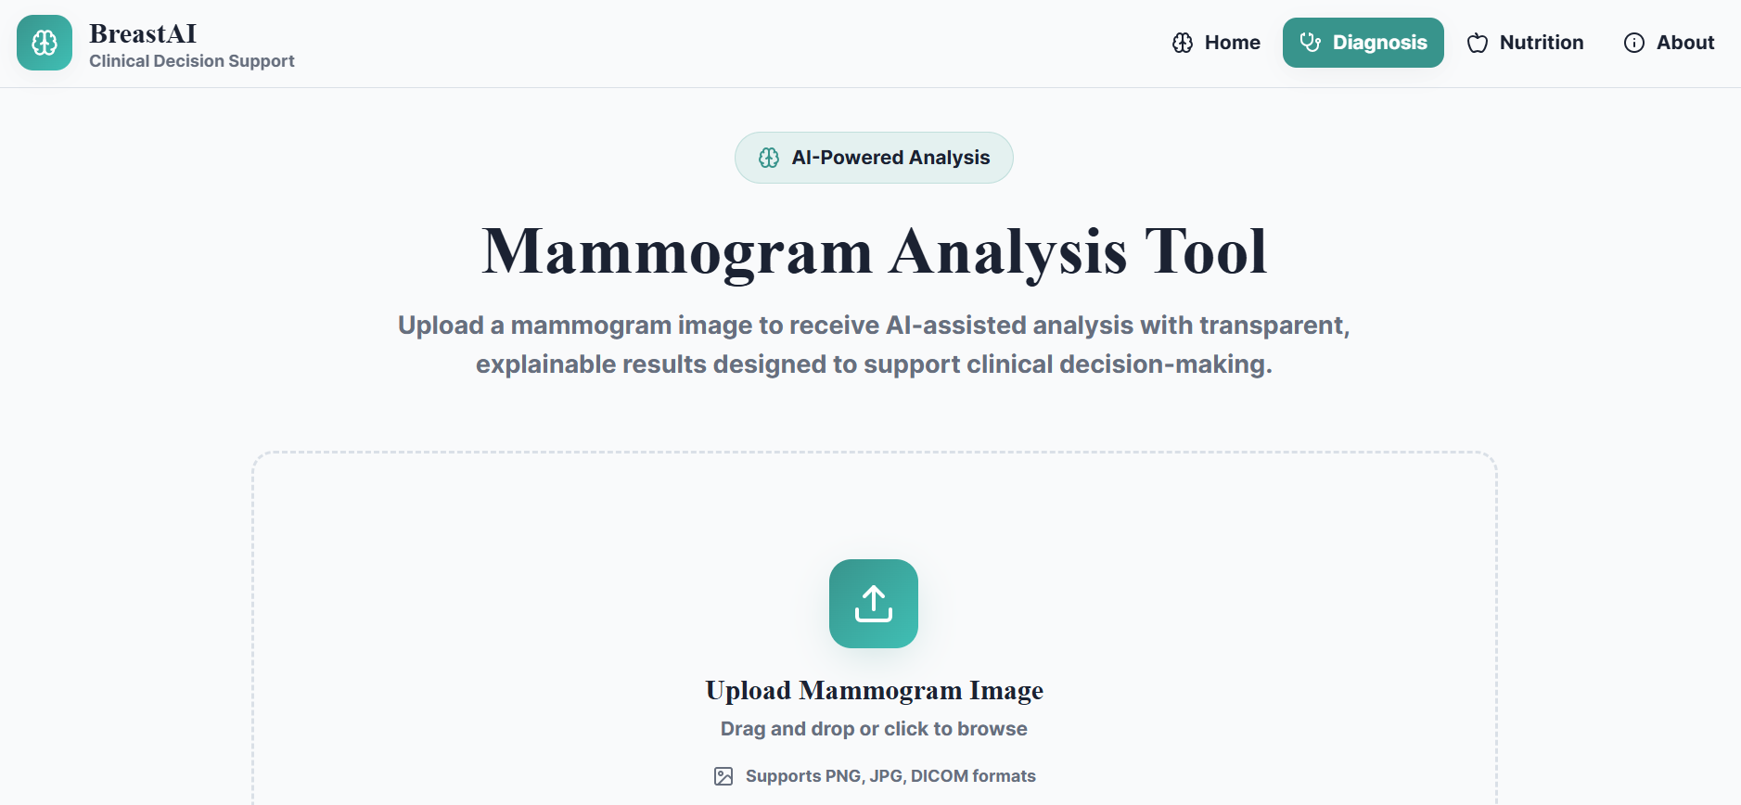

MALIGNANT TUMOUR

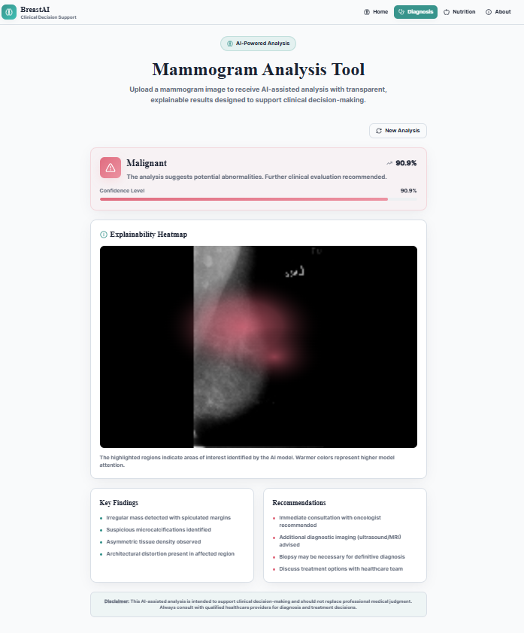

BENIGN TUMOUR
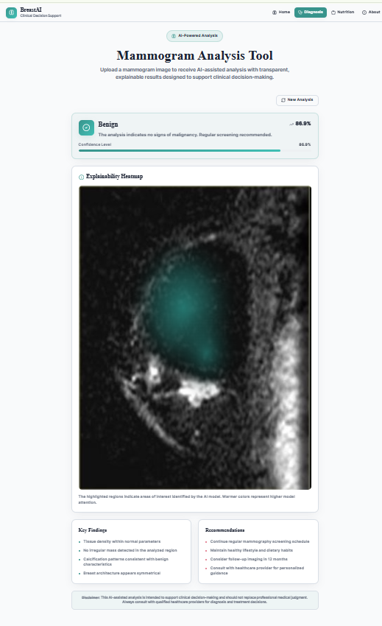

MODULE: NUTRITION


